

Lab 10: Create a VM with PowerShell

At the end of each lab, any resources you created in your account will be preserved. Some Azure resources, such as VM instances, may be automatically shut down, while other resources, such as storage services will be left running. Keep in mind that some Azure features cannot be stopped and can still incur charges (i.e. Azure Bastion). To minimize your costs, delete all resources and recreate them as needed to test your work during a session.

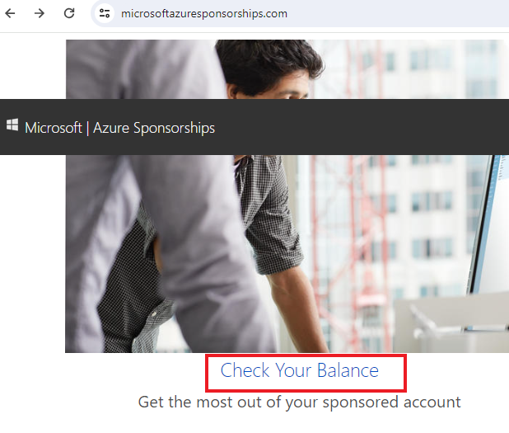

Reference: [AZ-900T0X-MICROSOFTAZUREFUNDAMENTALS](https://microsoftlearning.github.io/AZ-900T0x-MicrosoftAzureFundamentals)

# 10 - Create a VM with PowerShell

In this walk-through, we will configure the Cloud Shell, use Azure PowerShell module to create a resource group and virtual machine, and review Azure Advisor recommendations.

# Task 1: Configure the Cloud Shell (10 min)

In this task, we will configure Cloud Shell.

1. Sign in to the [Azure portal](https://portal.azure.com/) with your **odl_user_xxx** azure account
2. From the Azure portal, open the **Azure Cloud Shell** by clicking on the icon in the top right of the Azure Portal.

[Screenshot of Azure Portal Azure Cloud Shell icon.](https://microsoftlearning.github.io/AZ-900T0x-MicrosoftAzureFundamentals/Instructions/images/1002.png)

1. If you have previously used the Cloud Shell, proceed to the next task.
2. When prompted to select either **Bash** or **PowerShell**, select **PowerShell**.
3. When prompted, click **Create storage**, and wait for the Azure Cloud Shell to initialize.

# Task 2: Create a resource group and virtual machine

In this task, we will use PowerShell to create a resource group and a virtual machine.

1. Ensure **PowerShell** is selected in the upper-left drop-down menu of the Cloud Shell pane.
2. In the PowerShell session, within the Cloud Shell pane, create a new resource group.

CodeCopy

New-AzResourceGroup -Name myRGPS -Location EastUS

1. Verify your new resource group.

CodeCopy

Get-AzResourceGroup | Format-Table

1. Create a virtual machine. When prompted provide the username (**azureuser**) and the password (**Pa$$w0rd1234**) that will be configured as the local Administrator account on that virtual machines.

CodeCopy

New-AzVm -ResourceGroupName "myRGPS" -Name "myVMPS" -Location "East US" -VirtualNetworkName "myVnetPS" -SubnetName "mySubnetPS" -SecurityGroupName "myNSGPS" -PublicIpAddressName "myPublicIpPS"

** Wait for VM to deploy before closing PowerShell

1. Close the PowerShell session Cloud Shell pane.
2. In the Azure portal, search for **Virtual machines** and verify the **myVMPS** is running. This may take a few minutes.

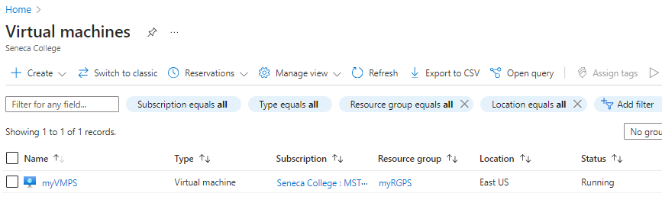

1. Access the new virtual machine and review the Overview and Networking settings to verify your information was correctly deployed.

# Task 3: Execute commands in the Cloud Shell

In this task, we will practice executing PowerShell commands from the Cloud Shell.

1. From the Azure portal, open the **Azure Cloud Shell** by clicking on the icon in the top right of the Azure Portal.
2. Ensure **PowerShell** is selected in the upper-left drop-down menu of the Cloud Shell pane.
3. Retrieve information about your virtual machine including name, resource group, location, and status. Notice the PowerState is **running**.

CodeCopy

Get-AzVM -name myVMPS -status | Format-Table -autosize

1. Stop the virtual machine. When prompted confirm (Yes) to the action.

CodeCopy

Stop-AzVM -ResourceGroupName myRGPS -Name myVMPS

1. Verify your virtual machine state. The PowerState should now be **deallocated**. You can also verify the virtual machine status in the portal.

CodeCopy

Get-AzVM -name myVMPS -status | Format-Table -autosize

# Task 4: Review Azure Advisor Recommendations

**Note:** This same task is in the Create a VM with Azure CLI lab.

In this task, we will review Azure Advisor recommendations for our virtual machine.

1. From the **All services** blade, search for and select **Advisor**.
2. On the **Advisor** blade, select **Overview**. Notice recommendations are grouped by High Availability, Security, Performance, and Cost.

[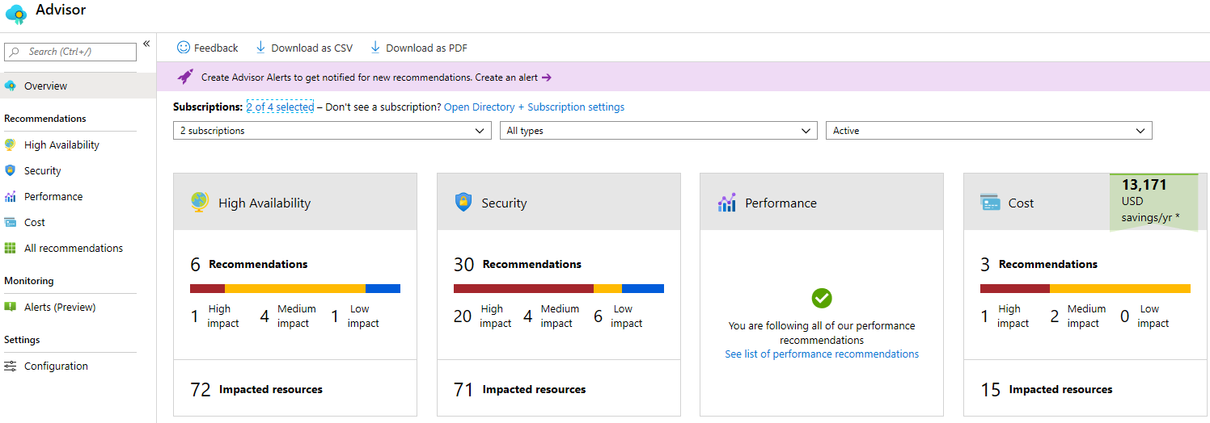](https://microsoftlearning.github.io/AZ-900T0x-MicrosoftAzureFundamentals/Instructions/images/1003.png)

1. Select **All recommendations** and take time to view each recommendation and suggested actions.

**Note:** Depending on your resources, your recommendations will be different.

[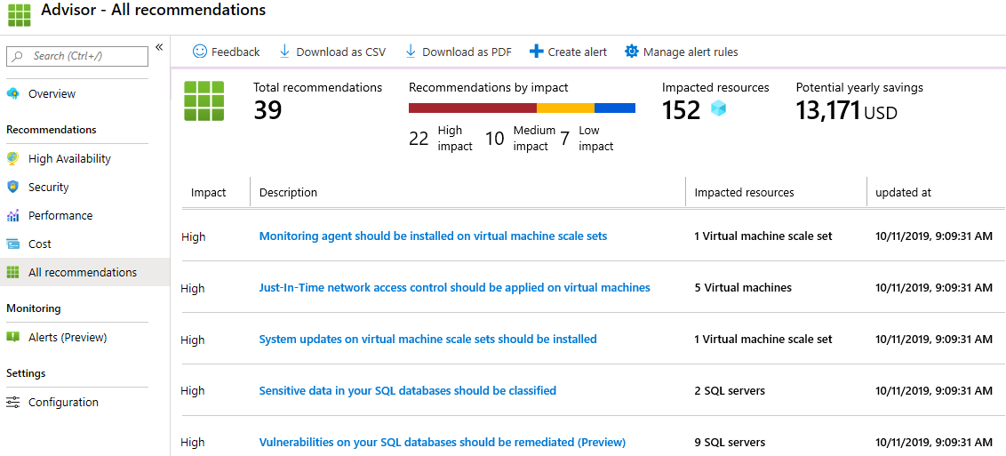](https://microsoftlearning.github.io/AZ-900T0x-MicrosoftAzureFundamentals/Instructions/images/1004.png)

1. Notice that you can download the recommendations as a CSV or PDF file.
2. Notice that you can create alerts.
3. If you have time, continue to experiment with Azure PowerShell.

Congratulations! You have configured Cloud Shell, created a virtual machine using PowerShell, practiced with PowerShell commands, and viewed Advisor recommendations.

**Note**: To avoid additional costs, you can remove all resources in the resource group. Search for resource groups, click your resource group, and then delete the resources within the resource group. **DO NOT DELETE YOUR RESOURCE GROUP.**

# Submission Requirements

Submit a screenshot with the following information:

**Screenshot #1:**

* Azure Powershell and Portal listing of the vitual machine’s status as deallocated
* The Azure Portal with your **CloudLab Account**
  + **Note**: underline the above items as described in the below picture

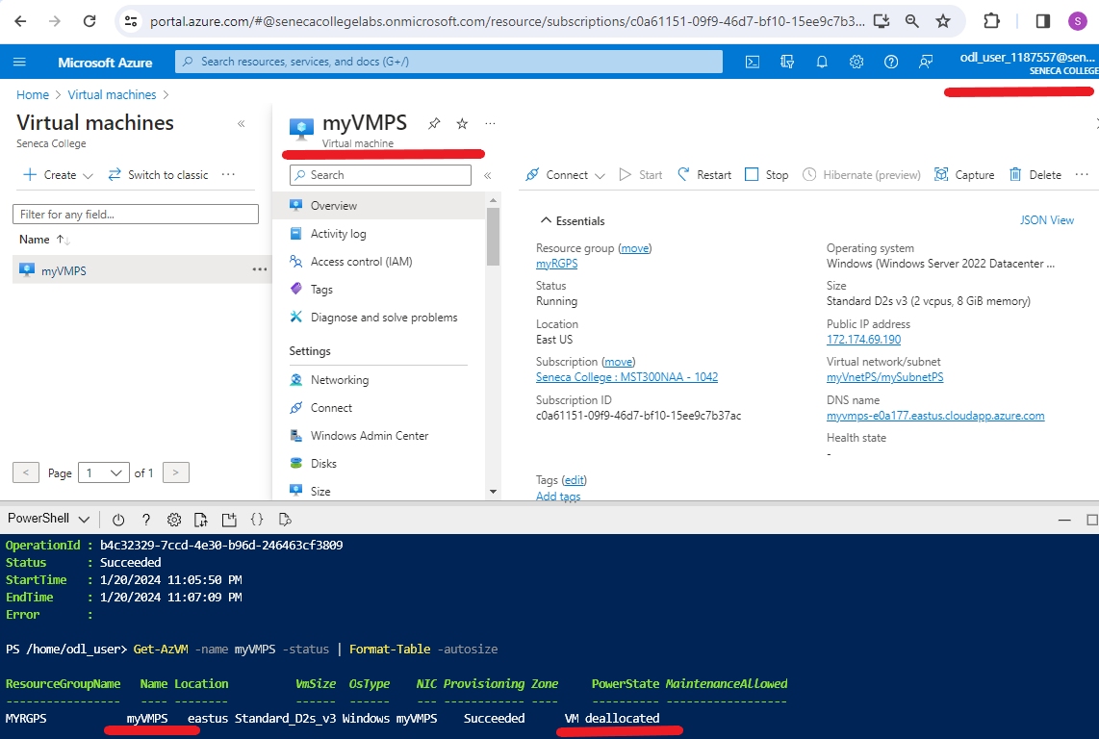

**Screenshot #2:**

* Successful deletion of all resources within resource group. **DO NOT DELETE YOUR RESOURCE GROUP!**
  + To delete all resources with a resource group, go to “**Resource Group**”, select “**MyRGPS**”, select all resources within the resource group, and select “**Delete**”

